Assignment Stage 1 Report - Group 26
36100 Data Science for Innovation - Spring 2025

Mason Pun | 25451713
Jiayu Hao | 25948860
Yan Hao | 25976440
Ting Chen | 25649649

Table of Contents
Section 1: Problem 2
1.1 Description 2
1.2 Research questions 2
Section 2: Literature review 2
2.1 Global Prevalence and Projected Trends 2
2.2 Health Consequences of Obesity 2
2.3 Societal Consequences of Obesity 3
2.4 Data-Driven Approaches to Obesity Research 3
Section 3: Approach 3
3.1 Data Understanding 3
3.2 Data Preparation 3
3.3 Modelling 4
3.4 Evaluation 4
Section 4: Data 4
4.1 Where did we acquire this data 4
4.2 Data Exploration 4
4.2.1 Overview 5
4.2.2 Distribution Analysis 6
4.2.3 Correlation Analysis 9
4.3 Data Preparation 13
List of Figures 15

Section 1: Problem

1.1 Description
Obesity is a major public health challenge worldwide, with the World Health Organisation estimating that global obesity rates have nearly tripled since 1975 [1]. It is a leading risk factor for chronic diseases such as diabetes, cardiovascular disease and certain types of cancers. However its reach is not limited to just society’s health, as obesity can impose significant economic burdens with increased healthcare costs and a reduction in workforce productivity.
In Latin America, where this dataset originates from, the prevalence of obesity has sharply risen over the recent years. According to the Pan American Health Organisation [2], nearly 60% of the adult population in the Americas is overweight or obese, with this rate having tripled in the region over the past 50 years. Obesity is a major health risk factor for many chronic diseases, and early identification of individuals at risk is critical to assist in providing preventative measures to help keep society in a healthy state.
Machine learning offers us the opportunity to develop a scalable approach to predicting obesity levels using lifestyle and physical condition data. Through analysing patterns and relations in lifestyle choices and eating behaviour, we hope to provide a predictive model that can support healthcare providers, policymakers and individuals in their decision making to allow them to live healthily.

1.2 Research questions

- Predictive Modelling:
  - What level of accuracy can we get on machine learning models that classify individuals into obesity categories (e.g., normal weight, overweight, obesity types I–III) based on eating habits and physical condition?
- Feature Importance:
  - Which lifestyle and demographic factors most strongly influence the obesity classification for this dataset?
- Model Optimisation:
  - How does limiting or manipulating our features set in combination with applying preprocessing techniques affect classification accuracy and interpretability?

Section 2: Literature review

2.1 Global Prevalence and Projected Trends
In most countries around the world, the rate of obesity is gradually increasing. Recent estimates suggest that by 2030, over 2.9 billion adults will have a high body mass index (BMI), with about 1.1 billion individuals meeting the criteria for obesity (BMI ≥ 30 kg/m²). This includes approximately 487 million men and 643 million women (World Obesity Federation, 2025). This highlights a concerning global trend that requires comprehensive research to examine the causes and solutions.

2.2 Health Consequences of Obesity
The health implications of obesity are well-documented. As highlighted in a study published by Nature Medicine, the consumption of sugar-sweetened beverages is associated with increased risks of type 2 diabetes and cardiovascular diseases, with long-term weight gain considered as a key contributing factor (Lara-Castor et al., 2025). Additionally, research indicates that persistent obesity contributes to chronic health issues, which results in diminished well-being and lower quality of life (Stephenson et al., 2021).

2.3 Societal Consequences of Obesity
The economic impact of obesity is also significant. A study estimated that in 2019 obesity-related costs accounted for 2.19% of global GDP, with spending amounts varying widely across countries: from $20 per person in Africa to $872 in the Americas, and from $6 in low-income countries to $1,110 in high-income countries (Okunigbe et al., 2022). These figures highlight the pervasive economic strain across diverse economic and geographic contexts as a consequence of obesity.

Based on the preceding analysis, evidence indicates that obesity exerts a substantial economic burden across nations, irrespective of geographic region or economic status, and this burden is projected to intensify if current trends persist. These findings underscore the urgent need for comprehensive strategies aimed at the early identification and effective management of obesity to mitigate its far-reaching consequences (WOF, 2025).

2.4 Data-Driven Approaches to Obesity Research
In response to the growing urgency of this issue, the scientific and medical communities have compiled extensive datasets to gain deeper insights into this condition, thereby enabling more effective diagnosis, prevention, and mitigation. To better understand and address obesity, researchers are using increasingly larger datasets and computational tools. Publicly available data, such as that from the UCI Machine Learning Repository, has enabled more effective diagnosis, prevention, and mitigation. For example, researchers employed this dataset to predict obesity levels using multinomial logistic regression in 2023, achieving a basic prediction accuracy of 82% (Srivatsan, 2023). Furthermore, the dataset has been used to classify obesity levels through attribute-based machine learning classification methods, which identified physical activity and nutritional habits as significant influencing factors (Gozukara et al., 2023). More recent work indicates that the random forest algorithm can achieve remarkable accuracy on this dataset following feature optimization (Değirmenci, 2025).

Section 3: Approach
Our approach is structured into four stages, following CRISP-DM, a well-known framework widely used within the data industry to ensure a reproducible and interpretable solution.

3.1 Data Understanding
This stage involves exploring the initial offering of the dataset, deriving insights seen through recurring behaviour and other dataset related exploration. As this will be covered as part of Stage 1, please see Section 4 for further detail regarding this.

3.2 Data Preparation
The dataset is largely already clean and complete, reducing the need for extensive preprocessing. However, targeted preparation steps will be undertaken to test their effects on the optimisation of the model’s performance:
- Encoding: Convert categorical variables (e.g., Gender, family history and other categorical features) into a numerical form using appropriate encoding methods such as Ordinal Encoding or One-Hot Encoding.
- Scaling: Applying standardisation to continuous variables to ensure comparability across features and to remove biases or weightings certain features may have on model performance.
- Feature Engineering: Create derived features such as Body Mass Index (BMI) to assist in improving model performance.
- Data Integrity Checks: To confirm that synthetic data generated via SMOTE does not introduce unrealistic feature combinations that could distort model learning. This can involve applying modelling on only real world data vs all data, and testing to check the differences in model performance.

3.3 Modelling
We will approach this classification problem using baseline models such as logistic regression, followed by more advanced setups such as Gradient boosting to compare different model’s performance. As we do not need to deal with class imbalance, due to the dataset having synthetically added data using SMOTE, we will not need any additional data to be generated. However, as part of further exploration, we will set up the test set to contain as much non-generated data as we can, to allow us to determine the model’s performance accurately as it will be compared against data that was collected directly from users.

3.4 Evaluation
In the final stage, we will evaluate the model’s F1-Score and Accuracy as the primary metrics for our research questions 1 and 3. The F1-Score provides a weighted combination of recall and precision, while accuracy gives us the raw performance metric. A combination of these two values will allow us to determine which model setup performs the best and would be the most practical to answer our research questions.

Furthermore, in order to answer Research Question 2, feature importance will also be explored for the models. The baseline logistic regression model will have its feature importance interpreted via coefficient magnitudes while for Gradient boosting, Permutation importance will be used to rank features. Determining the feature importance for the models built on this dataset will allow us to understand which lifestyle and demographic factors most strongly influence the obesity classification for this dataset.

Section 4: Data
A dataset estimating obesity levels based on the eating habits and physical condition of people in Colombia, Peru, and Mexico, includes 2111 records, no missing values.

4.1 Where did we acquire this data
This dataset is from UC Irvine Machine Learning Repository
https://archive.ics.uci.edu/static/public/544/estimation+of+obesity+levels+based+on+eating+habits+and+physical+condition.zip

4.2 Data Exploration

The dataset is first loaded for basic checks of the dataset, including its size, completeness, fields and data types, as well as the meaning of each column and what it represents in real life (e.g., lifestyle, eating habits). These checks ensure that the data is analysis-ready, and help us understand how the features may influence the target variable, obesity level.

Next, a distribution analysis is performed to examine how the data is spread across features. This helps us profile the dataset, and identify whether variables are imbalanced, whether they contain sufficient variation, and whether they are informative enough to be used in predicting obesity levels. These insights directly support our research questions on predictive modeling and model optimization (refer to 1.2).

Finally, a correlation analysis is conducted to explore relationships between key features and the target variable. This step also addresses our research question on feature importance (refer to 1.2) , as well as contributing to the other two questions.

4.2.1 Overview

The dataset contains 2111 entries and 17 columns, with the target variable "NObeyesdad". It includes a variety of features, covering demographic information (e.g., "Age", "Gender"), BMI, eating habits (e.g., "FAVC", "FCVC"), physical activity (e.g., "FAF", "MTRANS"), and more.

The dataset consists of a mix of categorical and numerical features and is fairly complete, with no missing values. Preprocessing steps, such as ordinal encoding and the creation of a complementary binary feature "is_obesity", were performed to enhance readability and to better explore the relationships between obesity and other features.

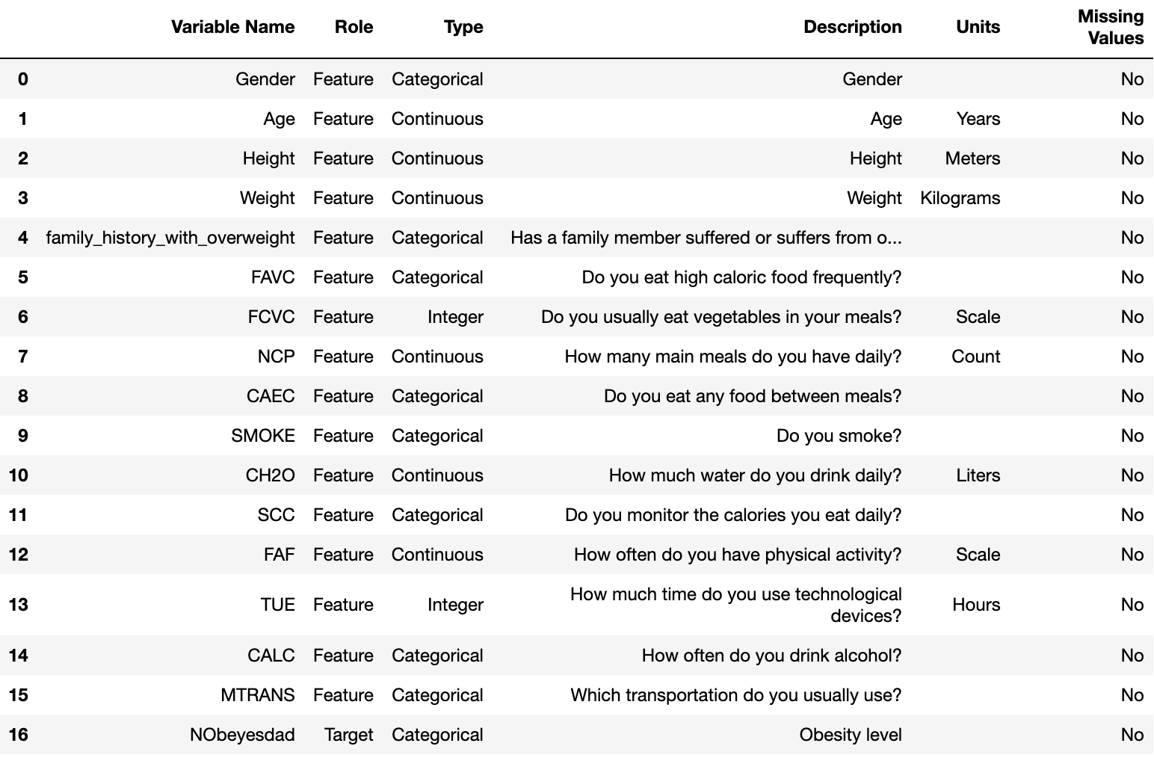

Figure 1 Dataset Description

4.2.2 Distribution Analysis

Target Variable
Our target variable "NObeyesdad" has 7 levels, and all obesity levels are fairly evenly distributed, except for Obesity_Type_I, which is slightly more prevalent.
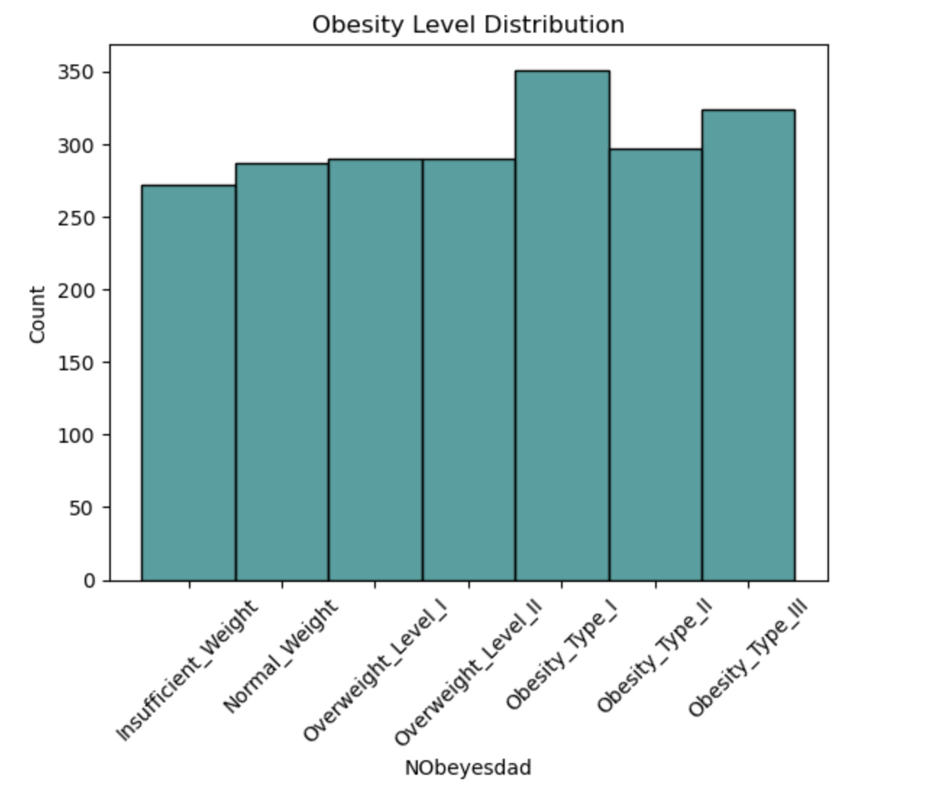

Figure 2 Obesity Level Distribution

Numerical Features
The samples of the dataset are mostly young, below 30s. Additionally, "NCP" (How many main meals do you have daily?) is dominated by 3, which indicates it may not be informative in this dataset, in terms of predicting obesity.
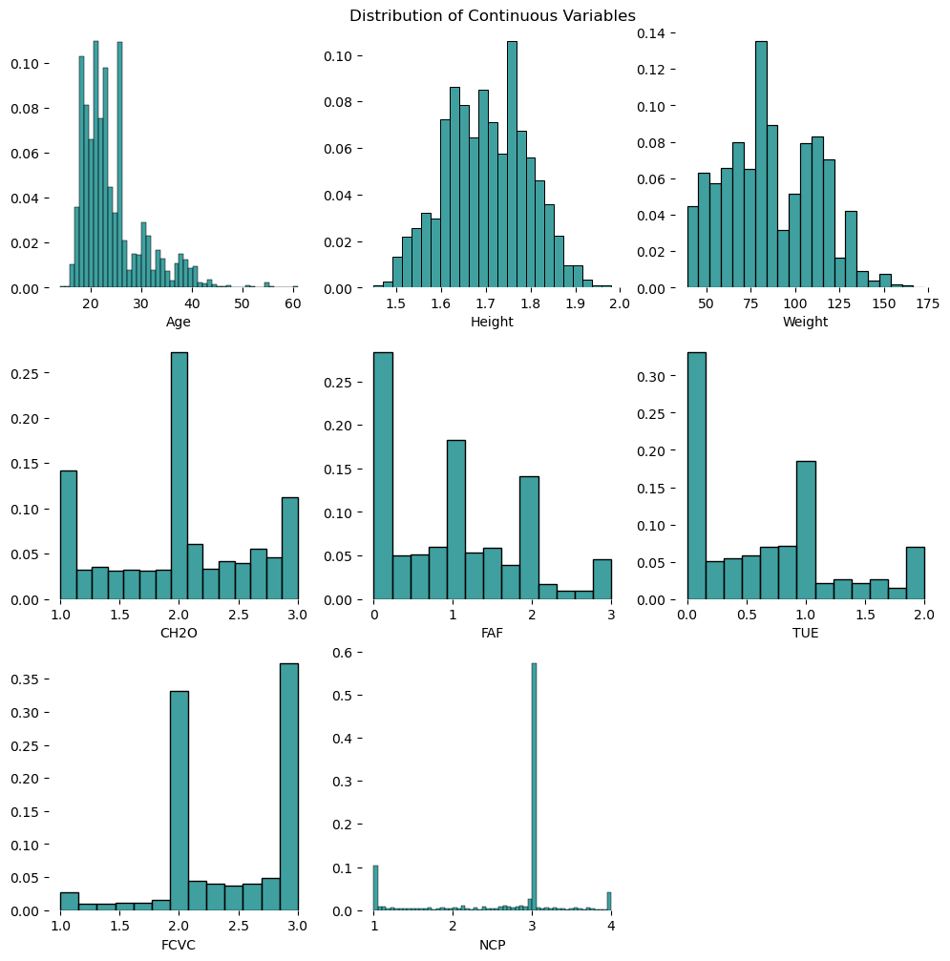

Figure 3 Distributions for Numerical Features

Categorical Features
Gender is fairly balanced in this dataset, but we do see some imbalanceness in features such as SMOKE', 'CALC', ‘SCC’ and more.

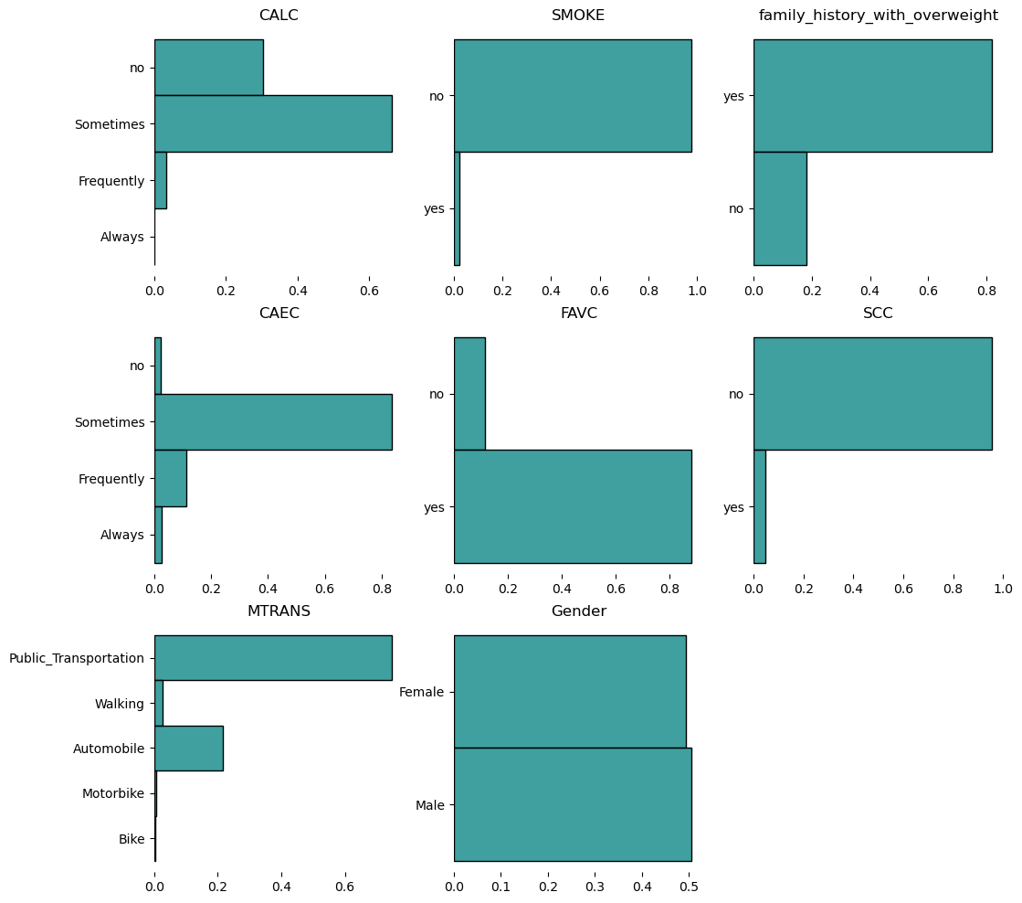

Figure 4 Distributions for Categorical Features

What do we know about the dataset？
Here is a simple profile portrait based on the dataset, focusing on demographic, lifestyle, and eating habit features that are dominated by one specific category or within a specific range (>50%). The main profile of individuals in this dataset is:

- Age: mostly young, below 30s

- Eating habits and awareness: frequently eating high-caloric food, typically having three main meals a day, and occasionally eating food between meals, generally not monitoring daily calorie intake

- Smoking & alcohol: non-smokers, but sometimes consuming alcohol

- Lifestyle/transportation: primarily using public transportation

Which features could be informative or contributable for modeling?
We expect potential features to be fairly distributed, providing more informative massage and variance to the model. In this case, we have a list of potential informative features for further attention and exploration: 'Age', 'Height', 'Weight', 'CH2O', 'FAF', 'TUE', 'Gender', 'FAVC', 'CAEC'.

Other features, though they may be dominated by specific range or categories, can still be helpful for drawing insights from analysis and models.

4.2.3 Correlation Analysis

4.2.3.1 Correlation Matrix (Based on "is_obesity")

From the matrix, the BMI index, especially Weight, shows a strong correlation with is_obesity (corr=0.79). In addition, Age also shows a correlation with the target variable (corr=0.22). For predictor variables, there is no significant correlation observed among them.

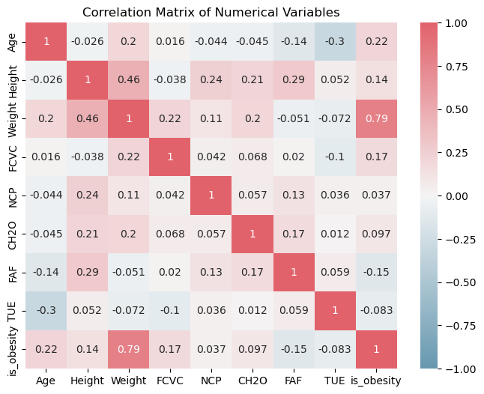

Figure 5 Correlation Matrix for Numerical Features

4.2.3.2 Correlation Crosstab (Based on "is_obesity")

There is a higher likelihood of obesity among individuals with a family history of being overweight.

Regularly monitoring calorie intake (“SCC”) appears to help prevent obesity. In contrast, those who frequently consume high-calorie foods are at greater risk ( “FAVC”).

Using public transportation or automobiles is associated with a higher risk of obesity compared to more active modes of transport, such as walking or biking.

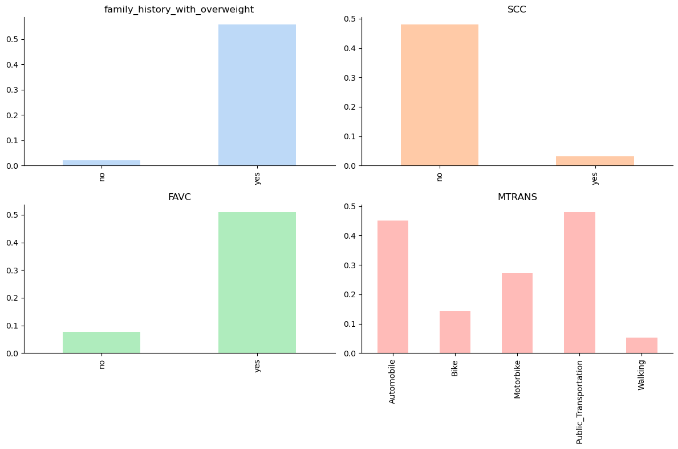

Figure 6 Correlation Crosstab for Selected Categorical Features

4.2.3.3 Deep Dive: Key Relationships

To better understand some key features, we conducted detailed correlation analysis on selected features in this part, in terms of the obesity level.

Height & Weight & Obesity Level
It's obvious that obesity is indicated by weight in relation to height. This is why we recommend introducing a derived feature Body Mass Index (BMI) for the later modeling part.

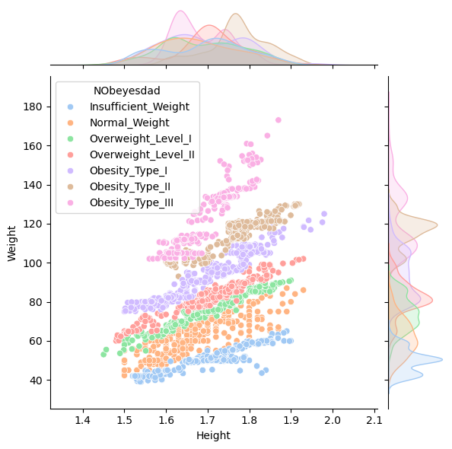

Figure 7 Pairplot for Weight and Height

Age & Obesity Level
Younger generations, around 20, are less likely to have obesity, while when they get older, they are more likely to gain weight, increasing the risk of getting obesity.

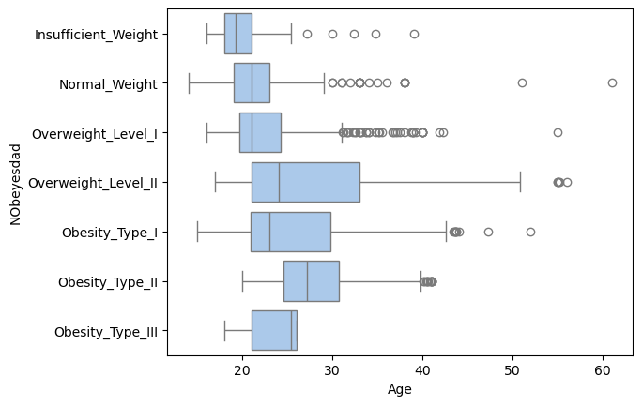

Figure 8 Boxplot for Age and Obesity Level

Physical Activity & Obesity Level
Those who do physical activity more than 2 times are less likely to have obesity type 2 or 3.

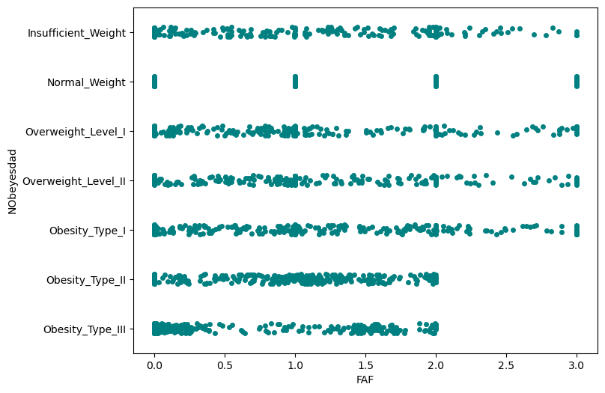

Figure 9 Stripplot for FAF and Obesity Level

4.3 Data Preparation
Data preparation primarily utilizes the pandas library, employing methods such as read_csv, quantile, median, loc, iloc, and sum.
Read the dataset using pandas and convert the four binary type fields(FAMILY_HISTORY, FAVC, SMOKE, SCC) in the data. Convert “yes” to 1 and “no” to 0. Eight floating-point and integer fields(AGE,HEIGHT,WEIGHT,FCVC,NCP,CH2O,FAF,TUE) were cleaned to remove invalid values. Five categorical fields(GENDER,CAEC, CALC, MTRANS, NOBEYESDAD) Convert to integers and create categorical dictionary.
Remove invalid numerical data.
Using Box Plots Method to Remove Outliers.
Box plots are charts based on the five-number summary method, used to display the distribution of a dataset, particularly its central tendency, dispersion, and skewness.These five numbers form the foundation of box plots, dividing the data into four intervals, each containing approximately 25% of the data points.

References

Değirmenci, A. (2025). Machine Learning Models for Accurate Prediction of Obesity: A Data-Driven Approach. Turkish Journal of Science and Technology, 20(1), 77-90. https://doi.org/10.55525/tjst.1572382

Gozukara Bag, H. G., Yagin, F. H., Gormez, Y., González, P. P., Colak, C., Gülü, M., Badicu, G., & Ardigò, L. P. (2023). Estimation of Obesity Levels through the Proposed Predictive Approach Based on Physical Activity and Nutritional Habits. Diagnostics, 13(18), 2949. https://doi.org/10.3390/diagnostics13182949

Lara-Castor, L., O’Hearn, M., Cudhea, F., Micha, R., & Singh, G. M. (2025). Burdens of type 2 diabetes and cardiovascular disease attributable to sugar-sweetened beverages in 184 countries. Nature Medicine, 31, 552–564. https://doi.org/10.1038/s41591-024-03345-4

Okunogbe, A., Nugent, R., Spencer, G., Powis, J., Ralston, J., & Wilding, J. (2022). Economic impacts of overweight and obesity: current and future estimates for 161 countries. BMJ global health, 7(9), e009773. https://doi.org/10.1136/bmjgh-2022-009773

Pan American Health Organization. (2023, March 3). World Obesity Day – PAHO urges countries to tackle main driver of NCDs in the Americas. https://www.paho.org/en/news/3-3-2023-world-obesity-day-paho-urges-countries-tackle-main-driver-ncds-americas

Srivatsan, S. (2023). Obesity Level Prediction Using Multinomial Logistic Regression. In: Manju, Kumar, S., Islam, S.M.N. (eds) Artificial Intelligence-based Healthcare Systems. The Springer Series in Applied Machine Learning. Springer, Cham. https://doi.org/10.1007/978-3-031-41925-6_2

Stephenson, J., Smith, C. M., Kearns, B., & Haydock, D. (2021). The association between obesity and quality of life: A retrospective analysis of a large-scale population-based cohort study. BMC Public Health, 21(1), 1990. https://doi.org/10.1186/s12889-021-12009-8

World Health Organization. (2021, June 9). 6 facts on obesity. https://www.who.int/news-room/facts-in-pictures/detail/6-facts-on-obesity

World Obesity Federation. (2025). World Obesity Atlas 2025. London, England: Author. Retrieved from https://data.worldobesity.org/publications/?cat=23

List of Figures

Figure 1 Dataset Description 5
Figure 2 Obesity Level Distribution 6
Figure 3 Distributions for Numerical Features 7
Figure 4 Distributions for Categorical Features 8
Figure 5 Correlation Matrix for Numerical Features 9
Figure 6 Correlation Crosstab for Selected Categorical Features 10
Figure 7 Pairplot for Weight and Height 11
Figure 8 Boxplot for Age and Obesity Level 12
Figure 9 Stripplot for FAF and Obesity Level 12

